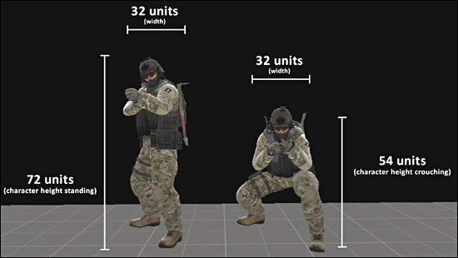**PLAYER DIMENSIONS**

Here are basic player dimensions.

* Player Height Standing: 72
* Player Height Crouching: 54
* Player Width: 32

**HEIGHT/WIDTH GEOMETRY CONSTRAINTS FOR PLAYER MOVEMENT**

* Minimum Player Height to Pass Under Standing: 73
* Minimum Player Height to Pass Under Crouching: 55
* 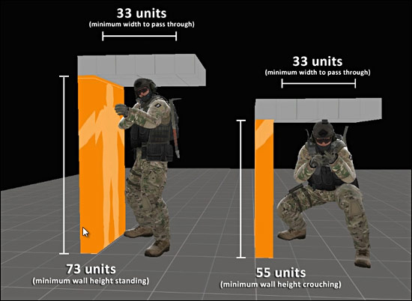Minimum Player Height to Pass Width: 33

**JUMPING HEIGHT**

* Jump (no crouch): 54
* Jump Crouch: 64

**MAXIMUM HEIGHT FOR WALKING OVER OBJECTS WITHOUT JUMPING**

* MaximumObject Height for Stepping Without Jumping: 18

**STAIR HEIGHT AND DEPTH**

* Stair Depth: 16
* Stair Height: 8

**AVARAGE WALL HEIGHT**

* Wall Height: 128
* 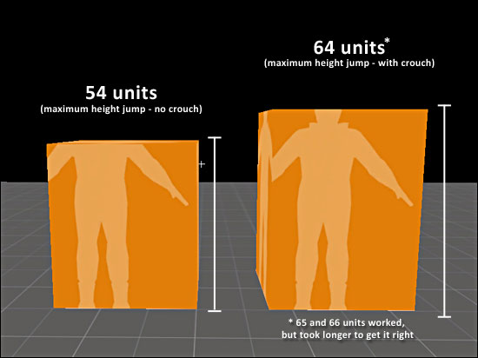Wall Depth: 16

**DOOR/WINDOW HEIGHT AND WIDTH**

Door and window height/width depends on the door prop model that you will use. Some doors are bigger, others slightly smaller. So this will vary case by case basis.

* Avarage Door Dimensions: 56X112

